DESCRIPTION | PHOTO | SIZES AVAILABLE | SIZE | QUANTITY | PRICE | TOTAL
CHILD’S NAME: |  | CLASS:
PARENT’S NAME |  | PARENT’S PHONE NUMBER & EMAIL ADDRESS
ARGYLL EAST SCHOOL UNIFORMS Our Uniforms are to be supplied by Personalise It
Gold polo shirt with school Logo Embroidered on left side of chest – Unisex | 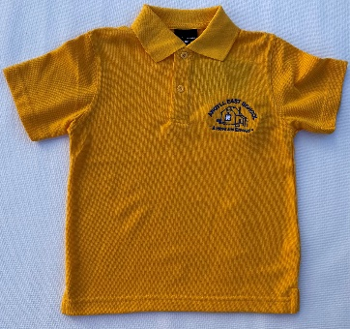 | 4, 6, 8  10, 12,  14  S, M, L,  XL |  |  | $32  $34
Royal Blue ½ zip Polar Fleece with school logo embroidered on left side of chest – option to have SURNAME added - Unisex | 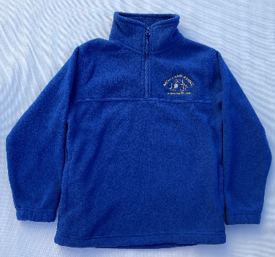 | 4 ,6, 8,  10, 12,  14  S, M, L,  XL |  |  | $40  $42

TOTAL

OPTIONAL EMBROIDERED SURNAME ON FLEECE – PRINT CLEARLY  TWO NAMES |  | $6  $10

You can Email this form directly to Personalise It – personaliseitnz@gmail.com
Internet bank to 030779 0010498 001 Personalise it.
Any queries contact Kiri Kirk on 0273768641. WINZ QUOTES & LAYBUY also available.

